Synopsis:
※The title page of the manuscript, which states the title of the paper, authors, etc., should be prepared using the application form. Please fill in the application form and upload the PDF file to the submission review system.
A Synopsis must briefly state the work's main objective, scope, and findings within 250 words. At least some Keywords must accompany the abstract.
□□□□□□□□□□□□□□□□□□□□□□□□□□□□□□□□□□□□□□□□□□□□□□□□□□□□□□□□□□□□□□□□□□□□□□□□□□□□□□□□□□□□□□□□□□□□□□□□□□□□□□□□□□□□□□□□□□□□□□□□□□□□□□□□□□□□□□□□□□□□□□□□□□□□□□□□□□□□□□□□□□□□□□□□□□□□□□□□□□□□□□□□□□□□□□□□□□□□□□□□□□□□□□□□□□□□□□□□□□□□□□□□□□□□□□□□□□□□□□□□□□□□□□□□□□□□□□□□□□□□□□□□□□□□□□□□□□□□□□□□□□□□□□□□□□□□□□□□□□□□□□□□□□□□□□□□□□□□□□□□□□□□□□□□□□□□□□□□□□□□□□□□□□□□□□□□□□□□□□□□□□□□□□□□□□□□□□□□□□

Keywords:
□□□□□; □□□□□□; □□□□□□; □□□□□□; □□□□□□; □□□□□□.

Main Styles of Template
Top and bottom margins: 35mm
Left and right margins: 25mm
Height and width: 26 vertical lines×42 horizontal characters
Font: Times New Roman
Font size: 11 pt
Bold for heading only
Page breaks before body text, tables, and figures
1. Introduction
This document is a template for submitting papers to ISIJ International. Advance online publications will also be published as per this template. For both the official online publications and paper-based publications the layout will be revised.

2. Regarding the Template for Submissions
2. 1 Setting up the Template
Since the paper size used in this template is A4, which is laid out vertically with 35 mm top and bottom margins, 25 mm left and right margins, 42 horizontal characters, 26 vertical lines, Times New Roman font, 11 pt. font size, it shall be used without amendment. The text should be page-break before the synopsis and body.
The settings of neither headers nor footers should be amended from their initial settings. Page numbers should be inserted on the right-hand side of the footer.

2. 2 Content included in the Template
All content to be posted should be included in the template. In addition to the text, all the charts, mathematical formulas, bibliography etc. shall be incorporated into the template so that they may be posted as is. In addition, regardless of whether other figures are used within the submission or not, a Graphical Abstract is laid out near the page containing the Abstract.

2. 3 Content to be submitted apart from the Template
In addition to the application form and the template (Word files) created here, the following files should also be submitted where applicable:
• high-resolution electronic data files of figures (including graphical abstracts) (if the figures in the template are not clear)
• Electronic data file of the table (if the table included in the template is an image)
• Data file of Supporting Information (if Supporting Information is to be included)

3. Points to note regarding the creation of Templates
3. 1 Formulas
When writing formulas, use Word functions to create them.
The formula should be centered in the line, assigned a number which would be placed on its right in half-width typeface, and enclosed in parentheses.

$L_{Cu}(\text{mol})≡\frac{N_{Cu (in Ca-Pb)}}{N_{Cu (in Fe )}}=\frac{γ_{Cu (in Fe)}}{γ_{Cu (in Ca-Pb)}}$ (1)

3. 2 Figures and Tables
At the time of official publication, the text is split into two columns. Consider the size of the figure (half width or full width) and place it close to the in-text description. Tables should be created using Word functions.
The captions of the figures and tables shall be listed below the figures and above the tables together with the number of the figure and table. The caption is inserted into the template itself, not included with the image of the table or figure. In addition to the figures and tables are shown below.
When a figure or table is submitted in color, it is automatically published in color in the online version as well. The phrase “(Online version in color.)” will be added to the end of the caption at the time of official release. If the author wishes for a figure or table to be published in color in the print version, the author should add the word “(color in print)” to the end of the caption. There is a charge for color publication in the print version.

3. 3 Supporting Information
If Supporting Information is to be attached, insert one blank line and write it as shown in the following example after Conclusions (with the URL of the DOI at the end). The URL will be added at the official publications.
“Supporting Information: [briefly describe the content]. This material is available on the website.”

4. Conclusions
When the manuscript has been completed using the template and the data files to be attached have also been prepared, submit the document from the following URL:
http://mc.manuscriptcentral.com/isijint
For detailed information on how to write the submission, refer to the “Instruction to authors” site. https://isijint.net/guide-to-authors/

Statement for conflict of interest
Authors are requested to declare any conflicts of interest related to the conduct of this research.

Acknowledgment(s)
If necessary. It is advisable to state the source of funding for the research. Acknowledgements to companies that proofread or reviewed the manuscript should not be included.

NOMENCLATURE (notation example)
u: Linear velocity (cm/s, at STP)
ε: Void fraction (–)
C: Concentration of gas (mol/cm3)
VB: Volume of bed (cm3-bed)

REFERENCES
1) ISIJ International Guide to authors, The Iron and Steel Institute of Japan, https://isijint.net/
guide-to-authors/, (accessed 2021-12-22).
2) ISIJ International Volumes & issues, J-STAGE, https://www.jstage.jst.go.jp/browse/
isijinternational/list/-char/en, (accessed 2021-12-22).
3) Welcome to the submission site for ISIJ International, The Iron and Steel Institute of Japan, https://mc.manuscriptcentral.com/isijint, (2021-12-22).

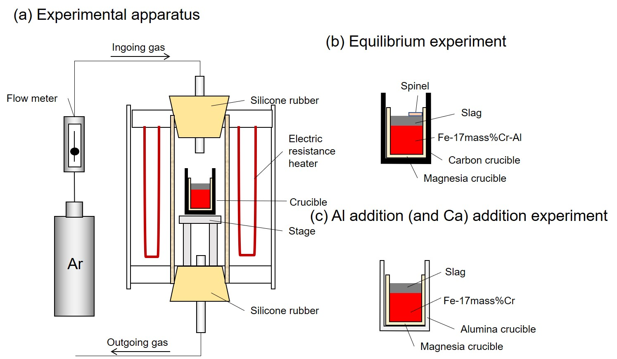
Graphical Abstract

Table 1 Experimental results of the Sn distribution between molten iron and Ca-Pb alloy.

Run No. | {mass%Ca}_{final} | {mass%Sn}_{final} | [mass%Sn]_{final} | L_{Sn}(mass)
Sn-1 | 11.6 | 0.750 | 0.130 | 5.77
Sn-2 | 26.9 | 1.388 | 0.061 | 22.7
Sn-3 | 47.4 | 0.995 | 0.020 | 50.4
Sn-4 | 61.8 | 2.287 | 0.005 | 439

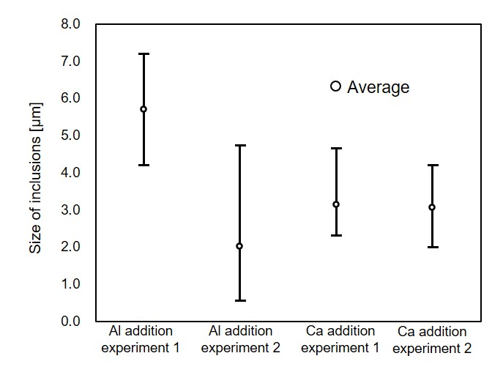

Fig. 1. Schematic illustration of (a) experimental apparatus, (b) sample arrangement for the equilibrium experiment, and (c) sample arrangement for the Al (and Ca) addition experiment.

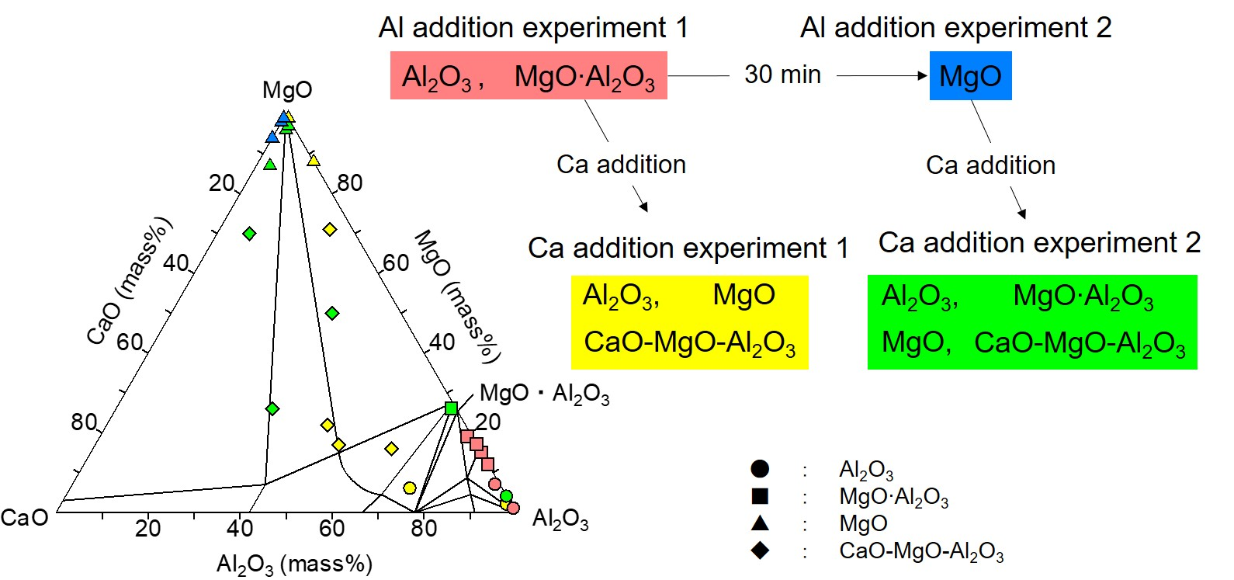
Fig. 2. Summary of the variation of inclusions observed in this work. (color in print)

